44.36: Squaring both sides of Eq. (44.13) and multiplying by 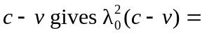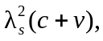 and solving this for v gives Eq. (44.14).

